The Great Pyramid – the way it was built

THE BACKGROUND

Building the pyramids in Egypt was perhaps the greatest project undertaken by man. It compares with putting a man on the moon in terms of resource, planning, skills and leadership but how was it done? This has been one of the World’s most fascinating mysteries for hundreds of years – until now.

That the Egyptians used barges to move stones is not in doubt. Nor is the method used to quarry the stone blocks that are remarkably ‘square’, but the all the methods suggested to lift the blocks, such as dragging them up long ramps to the construction layer are now discredited. Those ideas that cannot be disproved are far from convincing – though anybody who wants to know more, can find hundreds of web sites and arguments for and against both sensible and ridiculous propositions.

The numbers are staggering… The great pyramid is built of some 2.3 million stone blocks each weighing typically 2½ tons giving a total weight of some 6½ million tons. The pyramid is built of nearly 200 layers of rectangular blocks with the top 145 metres or 480 feet above the base.

Have we eventually found the right answer to the mystery? We are sure the answer is YES - but only because it was developed logically from simple physics - and it can be proven.

THE PROJECT

Our small team started the research by listing the following:
- known facts such as local boat sizes - up to 40 metres long and 7 metres wide.
- resources available to the Egyptians such as large numbers of farmers who were available to work during the Nile flood season. Other resources included unlimited sand unlimited water and almost unlimited stone.
- knowledge that was available, especially water engineering including the obvious fact that boats can carry very heavy loads.
- capabilities such as canal construction and simple locks to keep water within irrigation ponds.
- limitations such as poorly developed wheels and ropes - and very hot weather.
- other factors such as travel being mostly limited to going up or down the river and a long periods without war.

The next step was to make and test assumptions. Two useful assumptions were:

The builders knew before they started that despite the enormity of the project it was almost certain to be successful.

During the annual flooding (or inundation) of the Nile there had been a significant overflow of water into the depressions of the Western Desert near the Giza plateau, forming a seasonal river that might provide water power.

THE CONCEPT STEPS:

1 A boat goes up and down with the water level, as does a boat in a canal lock.

2 A boat can support great weights (equal to the weight of water displaced as Archimedes famously declared) so a 40 x 7 metre boat pit could carry 200-400 tons.

3 For a lock to work (and for boats to repeated go up and down) there has to be a supply of water to fill the lock and somewhere for the water to go when emptying the lock.

4 Imagine a lock near the pyramid, supplied by the Nile in full flood and drained into the desert the other side of the Giza plateau, some of which is below sea level. By operating the two lock gates a boat in the lock can be made to rise and fall every few minutes.

Let us say the boat in the nearly empty lock with its deck at ground level has a stone block pushed or slid onto it. The boat will settle a little lower in the water. When the water level next rises, the boat and stone block also rise.

If we build a dock-side platform at the right height next to the boat, the block can be slid onto the platform before the boat drops down again when the lock empties. How can we move the stone up a second time (from its position on the platform)? Well, if we put a strong table in the boat when the boat is in its lower position, we can slide the block onto the table in the boat. When the boat again floats upward the block will be lifted a second time and could be slid onto a platform twice the height of the first platform. With 10 tables on top of each other of say one metre high and 10 shelves one above the other also a metre apart, it would be possible theoretically to move the block up 10 metres in height using only the power of water rising in the lock.

The team thought that handling the blocks so many times might be impractical, even if the basic physics was right. There were other engineering objections as well so the team designed and built a 100:1 working scale model of the ‘machine’. Only materials and knowledge available to the ancient Egyptians were used – just stone and wood.

The model works. It uses a boat of similar size to the one discovered in the boat pit next to the great pyramid (40m by 7m, scaled down to 40cm by 7cm. For model dimensions read cm instead of m, gm instead of tonne etc). Stone blocks and tree trunks provide 10 levels of ‘tables’ and ‘platforms’ with each layer spaced 5m above the one below. The model is quite capable of moving 10 loads at a time (one on each platform or ‘table’) upwards to a height of 50m. If the lock is worked on a six minute cycle, the model will move 10 loads per hour from the lock level to the top (construction) level.

Using the model, it has become clear the blocks need to remain on a pallet or sled all the time they are in transit. This makes it much easier to slide the blocks on and off the tables or platforms. The work is also much easier if the skids are grooved underside and slide on horizontal timber runners (tree trunks again).

If the timber runners are free to move a little and if a small block is placed under the centre of each runner, so the runner see-saws a few degrees, the runners can be wedged so the sliding of the block/skid is downhill whether sliding it from the platform or from the table. As the sliding action is always downhill, it will allow a loads to be moved (the 2m or so) on or off the platforms by only a few men with simple levers (crowbars) in a minute or two. This technique significantly reduces the manpower to make the “lift” work and allows for larger loads to be moved on each sled.

THE FIGURES:

The great pyramid is built mostly of 2-3 ton cubes of limestone with 0.8m sides. The scale model works well with loads of up to 8 blocks per sled weighing about 20 tonnes. The model will run at one up-and-down cycle per minute delivering 60 loads of 20 tonnes per hour, or for a 15 hour day: 18,000 tons per day. In reality an up-and-down cycle time of 6 minutes would be more practical, giving 10 loads per hour of 20 tons, or 3000 tons per day. In the case of the 10-platform working model the 3000 tons are delivered to a height of 50 metres (about 160 feet). This boat lifting capacity means that a 15-platform version would deliver some 2000 tons a day to a height of 75 metres. 90% of the total mass of the pyramid lies below this level.

Based on simple tests with pallets, the team estimates each platform/table would need about 6 men to lever/slide a sled of 20 tons at each stage. With 10 stages this requires 60 men that might work for a 3 or 4 hour shift – a relatively very small fraction of the workforce. Six men working one sled would probably get in each other’s way, so 2 ½ or 5 ton loads requiring 2 or 3 men might have been more practical, after all there is no reason not to have 2 or 3 machines running with smaller loads.

In essence, the ‘machine’ would allow the great pyramid to be built in 10-20 years by relatively small numbers of workers, the lifting operations requiring a team of only 100 men

PYRAMID FIRST OR MACHINE FIRST:

When the model was built it became clear that any ‘machine’ more than a few shelves/tables high resembled a lift shaft with power-providing boat underneath. This presents some clear engineering risks in terms of stability and safety of the whole structure. The scale model has the ‘lift shaft’ built over a boat pit next to the pyramid. But as the height of the works and ‘lift shaft’ gradually increases it becomes clear that the support for the ‘lift shaft’ requires all round support, probably a sloping structure of stone block, especially for the higher levels. This means that the lift shaft requires a pyramid of stone blocks to support it all round – and the pyramid requires the shaft in the middle to be able to build the pyramid. The two are mutually dependent.

Models may be all well and good but does theory support the scheme? Well the annex contains some calculations albeit based on certain assumptions but it is apparent that the machine uses some 500 times less human energy to lift the blocks into position, than a ramp and teams dragging blocks.

The scheme suggests there must be one or more shafts running vertically through the pyramids and a canal tunnel running in near ground level for boat or barge deliveries of stone to the base of the ‘lift’. The shafts and tunnel would be filled in afterwards, but some evidence, especially for the vertical shafts will still be there within the pyramid and should not be too difficult to discover as part of a research project.

OTHER POSSIBLE ASPECTS

Why are pyramids only found on the West of the Nile? There is no obvious drain for the water on the East bank but the land on West bank shelves down into the Western Desert. Even if a trench had to be dug the 30 odd miles to Waddi el Natrun, a lake that is below sea level, the effort would be small in comparison to the benefit of using the ‘machine’.

The missing cap stone. Constructing the top layers would require stacking extra blocks on the highest layers for the final filling in of the shaft. The large capstone would not have been cube shaped and would have been awkward to stack and subsequently move into position. Is it possible that whilst moving the capstone into place, it slipped and slid down the side of the pyramid, and with no way to move it back to the top it was always going to be missing.

Supplies of water. Nile water supply is the most obvious but the very large Lake Qarun to the South of Giza overflows down waddis towards Giza and could be diverted (maybe via man made canal) to the pyramid sites. Initial research suggests the Nile water was the most likely source.

How did the technology come to be used? It would have been common knowledge that boats can carry and ‘lift’ big loads as the Nile was not only the motorway of the day, it was almost the only transport route for anything.

Before the various Aswan dams were built from the 19th century, the Nile flooded every year and provided irrigation for crops for some miles each side of the normal riverbank. At one time we suggest the flooding waters found a route into the Western Desert and rapidly formed a small river valley. Damming the river would be natural in order to maximise the local irrigation thus forming a simple lock. Trial and error and some imagination probably did the rest.

Why has the technique been forgotten? Once the wheel was developed, the opportunity for war, travel and a more active society was greatly enhanced, and history bears this out.

Is there any historical evidence? The most famous of the Greek historians, Herodotus writing some 500 years after the temples were built and more than 2000 years after the pyramids were finished, suggests the pyramids were build using a ‘wooden machine’. The team had thought such a machine was impossible but now sees it as essentially correct and the only way the pyramids could have been build. There is no information (to our knowledge) about temple building though the method could have been used on a smaller scale on the East bank of the Nile where most temples were built.

DIAGRAMATIC REPRESENTATION

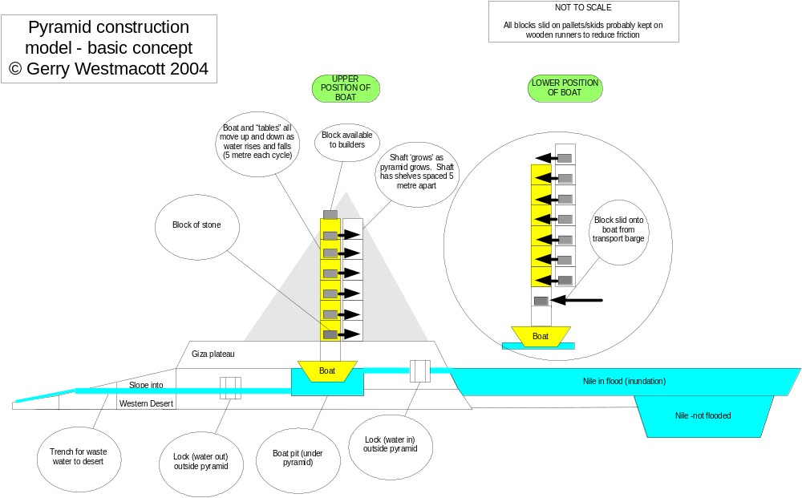

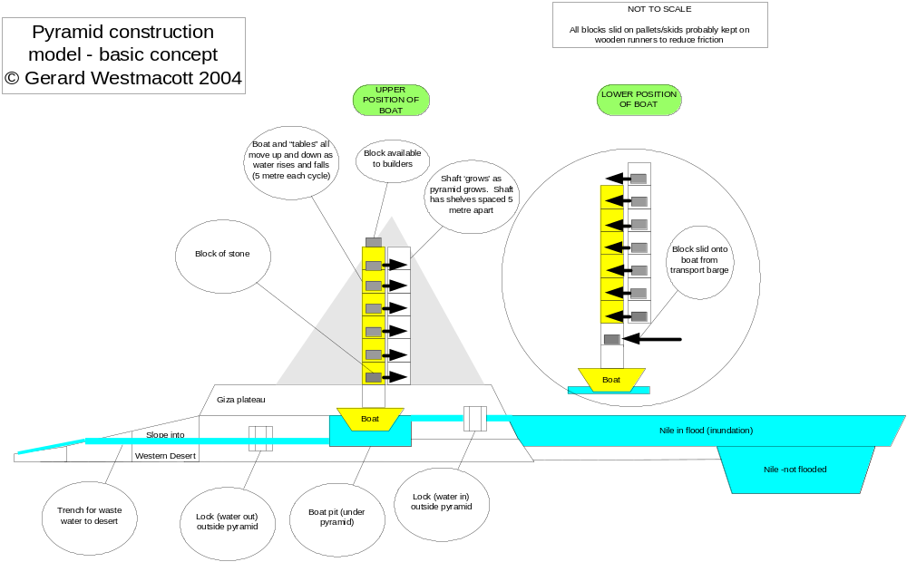

Annex:

Theoretical comparison of dragging blocks up a ramp and using the ‘boat lift’ hoisting system.

Assumptions and facts:

- Mass of Great Pyramid as given on several web sites: 6 ½ m tonnes (6.5 x 10⁹ kg)

- 4-sided pyramid centre of gravity (c of g) is ¼ way up central vertical line

- The height of the Great Pyramid was effectively 145 m, the c of g being approx 145/4 or 38m above base level.

- Ramp for dragging blocks - 400 m long (for average case of moving stone block to c of g of the pyramid). This is approximately a 10 degrees slope.

- Coefficient of friction for dragging block: 0.1 (probably too optimistic but could be this low if hard wood rollers or rails were used)

- A human can lift 50kg (about 100lbs) to a height of 1 m, once per minute (A local 24 year old farmer using sacks of grain can manage this for 30 minutes). This figure may be over optimistic bearing in mind the hot climate.

- Men were available all year, including during farming seasons.

Case 1 – dragging blocks up a ramp

Work (element 1) to provide potential energy in lifting the blocks is on average:

6.5 x 10⁹ x 38 = 2.47 x 10¹¹ m kg

Work (element 2) to overcome friction and drag blocks up 400 m ramp:

6.5 x 10⁹ x 400 x 0.1 = 2.6 x 10¹¹ mkg

Work elements (1) plus work (2) = (2.47+2.6) x 10¹¹ = approx 5 x 10¹¹ m kg (value A)

Human work capacity: 50 m kg per minute

Or 50 x 60 (mins) x 10 (hours) = 3 x 10⁴ m kg per day (working 10 hours a day)

So a man can deliver (in a 300 day year): 3 x 10⁴ x 300 m kg = 0.9x 10⁷ m kg (Value B)

Dividing Value (A) by Value (B) gives the number of years required just moving the blocks to the right location:

This is 4 x 10¹¹ / 0.9 x 10⁷ = 3.6 x 10⁴ or 36,000 man years.

2,000 working at any one time allows 18 years for completion. This is theoretically possible but assumptions have been generous including the idea of a 10 hour shift and no logistics or support people. Applying some common sense taking into account the demands of farming and some inefficiency, the team thought that 2 or 3 shifts of 2,000 workers might take 50 years or more. This conclusion took into account that more than 2,000 workers would be very difficult to manage due to congestion on the ramps.

Other estimates published on the World Wide Web and elsewhere are generally much higher with suggestions that a work force of up to 100,000 would be needed to build the great pyramid within 20 years, the generally accepted time it took.

Case 2 – using a ‘boat lift’

Assume slides from barge to lift slopes down at 1:50 – assume one slide 4 m long

Assume slides from 8-stage lift slope down at 1:50 – assume 8x 2 m or 16 m long in total. (an eight stage machine of 5m steps will take blocks to the centre of gravity, 38 metres above ground level, which is the average height blocks need to be raised). We use the same coefficient of friction as before (0.1) but as the load is moving downwards the effective coefficient is lower. Experiments and calculations provide inaccurate figures but the team concluded the friction would seem to be half the normal - ie 0.05

So 4 +16 = 20 metres of sliding is required for every block/sled

Work to drag blocks along 20m (friction): 6.5 x 10⁹ x 20 x 0.05 = 6.5 x 10⁹ m kg

Human work capacity: 50 m kg per minute or 0.9x 10⁷ m kg per year as before

Man years required = 6.5 x 10⁹ / 0.9 x 10⁷ or 700 man years

The team see this best expressed as a team (or shift) of 70 working on the lift for 10 years

This ‘effort’ is some 500 times less than the ‘ramp’ option

